Title: The Military Importance of Hilton Head Island during the Civil War and the Physical Development of Mitchelville.

Grade Level: 3, 4, 8

Standard Indicators: 3-1.3, 4-6.4, 4-6.5, 8-3.5, 8-3.6

Literacy Elements:

- Locate Hilton Head Island on a map of the east coast of the United States in relation to major seaports/cities of the 1800’s.
- Interpret the geography of Hilton Head Island.
- Explain the relationship between Hilton Head Island’s geographic location and its importance to the Civil War effort.

Essential Questions:
(The following essential questions are numbered to align with the above Literacy Elements.)

- What major United States cities were located along the Atlantic in the 1800’s? (Literacy Element 1)
- How did Hilton Head Island’s location along the east coast of the United States affect early wartime military decisions? ( Literacy Elements – 1,2,3)
- What physical characteristics of Hilton Head Island impacted on the development of Mitchelville? (Literacy Elements – 2,3)

Terms to Learn:

- Blockade
- agrarian
- Battery
- Plantation Task System
- Acre
- economy

Mini-lessons:

The American Civil War began on April 12, 1861, when the Confederate shore batteries under Gen. Pierre G.T. Beauregard opened fire on the Union held Fort Sumter in South Carolina’s Charleston Bay. Fort Sumter, at that time, was a Union fort in a state (South Carolina) that had seceded from the United States. When the CSA got word (April 11, 1861) that President Lincoln planned to resupply the fort as a Federal outpost in the harbor of Charlestown, SC, they demanded the fort’s surrender. The commander of Fort Sumter refused. The next day the fort was captured by the Confederate army.
Three days after the fall of Fort Sumter, President Lincoln ordered a blockade of all southern ports. The South’s economy was agrarian-based with virtually no factories. Therefore, manufactured goods were purchased from Great Britain with money earned through the sale of cotton. A blockade of Southern ports would greatly cripple the South’s war effort.
The primary Confederate ports to block were Charleston, SC and Savannah, GA. But blockading ships spent as much time traveling to and from their refueling stations as they did on duty. The solution, then, was to locate a suitable port to transform into a refueling station along the southern coast. This location was Hilton Head Island.

Classroom Discussion Questions:
- How many ships/men were involved with the capture of Hilton Head by the Union forces?
- Once the island was captured, what events occurred that lead to the establishment of Mitchelville?
- With the maps, photographs and illustrations of Hilton Head Island you have viewed, how did the development of Mitchelville help/hinder the independence of the freedmen?

Learning Activities:
- Examine historical photographs and maps of the Atlantic Coastal area
of the United States in the 1800’s to identify the major coastal transportation hubs.
- On a flat area around your school, outline with chalk a quarter acre to demonstrate the size of a plot of land given to the freedmen.
- Construct a table to show the number of whites and nonwhites on the island in 1861 and 1865.
- List the available jobs for the freedmen living in Mitchelville during the Union occupation of Hilton Head Island.

Learning Assessments:
- Using primary/secondary sources, construct a graph to show the population (white/nonwhite) on Hilton Head Island in 1861, 1864, and 1867.
- Construct a poster to illustrate a typical neighborhood in Mitchelville. (Label illustrations)

Sources – Primary and Secondary:
- The Forgotten History- A Photographic Essay on the Civil War Hilton Head Island, 973.73McC
- Mitchelville: A Compilation of Research Article 2010, 975.799MIT
- Civil War, Hilton Head, and the Evolution of Mitchelville, 975.799MIT
- Maps, articles, and illustrations available at the Heritage Library:

Coastal Survey Map 1861

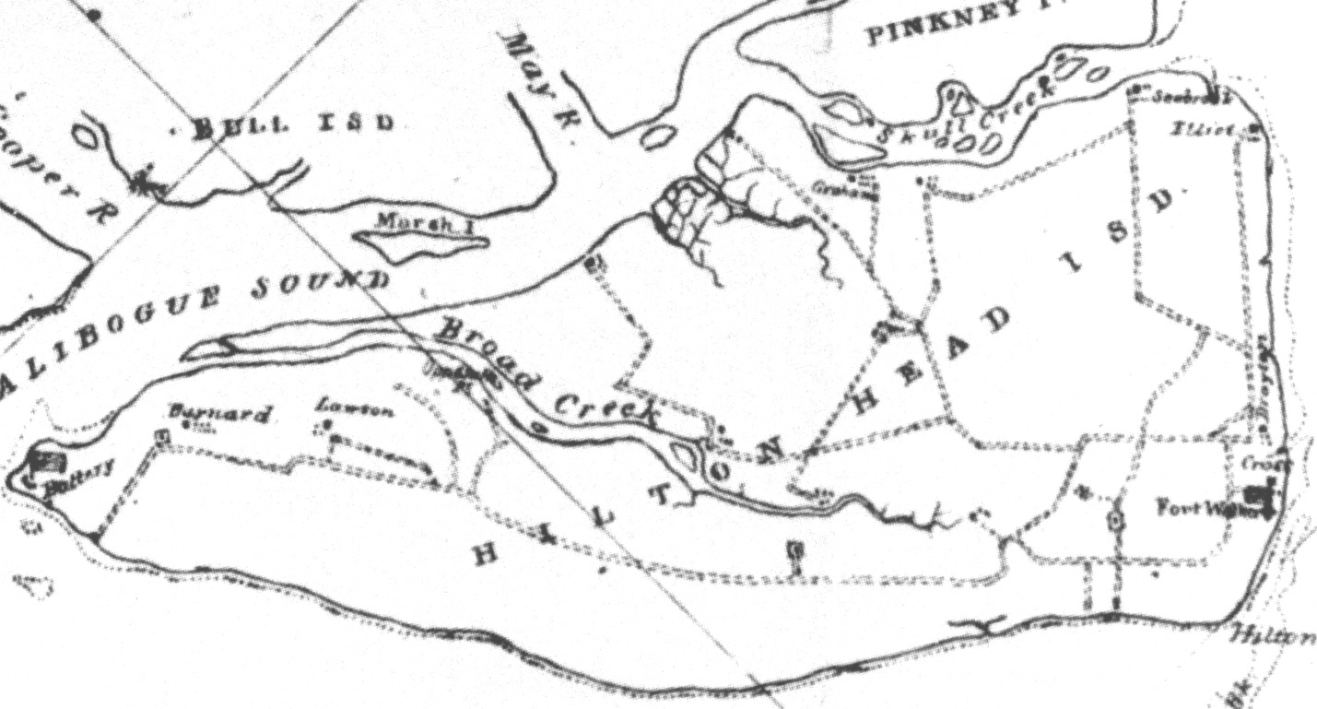

The following is a list of the individual Maps in the Library’s collection. It has been arranged alphabetically by states or countries, and then place names.

Carolinas, North and South 1861
Carolinas, North and South 1875
Carolinas, North and South, 1896
Georgia, Camden City, - 1953
Georgia, Historic Map of, DAR, undated
Georgia , Province of: Coast, Rivers & Inlets, 1780
Germany, Maps of, 1780 & 1875-5????
Ireland, Ancestral Map of
Ireland, "The Kingdom of Ireland", 1620
New York, New York and Brooklyn 1866 engraving
New York, New York, Composite Map of, undated South Carolina, Beaufort City Map
North Carolina, 1585
North Carolina, 1590
North Carolina, 1657
North Carolina, 1672
North Carolina, Map of,1733
North Carolina, 1770
North Carolina, 1808
North Carolina, 1833
North Carolina, 1882
Regional, Bird's Eye View of N.C., S.C. and Part of Georgia, 1861
Regional, Eastern United States, Appalachian Trails to the Ohio River
Regional, U.S. Coastal Survey, 1865
Regional, Virginia to Florida (Coastal) Map 1606
South Carolina, Bluffton Quadrangle, Environmental Map
South Carolina Counties Map c. 1900
South Carolina, Daufuskie Grant - Christopher Dawson to Philip Martinangel
South Carolina , D'awfoskee Map - Gascoigne Map - 3 copies
South Carolina, D'awfoskie, River & Sound of, Gascoigne Survey
South Carolina, Hilton Head Island, Department of Mines - Drill Holes c. 1950
South Carolina, Hilton Head Island, Dr. Mosse's Survey - Spanish Wells
South Carolina, Hilton Head Island, John Bull's Grant and Map
South Carolina, Hilton Head Island, John Bull's Plantation , Survey of, 1763
South Carolina, Hilton Head Island Quadrangle, Environmental Map
South Carolina, Hilton Head Island, Sea Pines Plantation, Modem
South Carolina, Hilton Head Island, Shipyard & Port Royal Plantations, current Land Use Plans
South Carolina, Hilton Head Island, 2004
South Carolina, Hilton Head Island, Very Early Map, poor condition
South Carolina, Parris Island Quadrangle, Environmental Map
South Carolina, Pocotaligo. 1862
South Carolina, Port Royal & Hilton Head Island - Gascoigne Map
South Carolina, Port Royal, Plan of - Gascoigne Survey
South Carolina, Spring Island Quadrangle, Environmental Map
South Carolina, Sumter District, 1825

Hilton Head Today
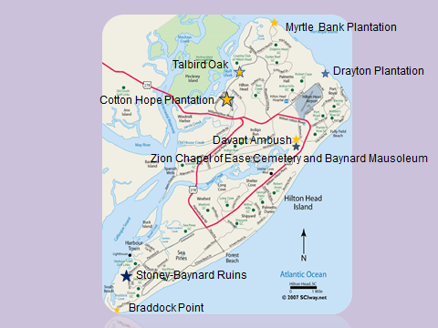

Myrtle Bank Plantation - The foundation of the plantation house can be seen from Dolphin Head Park in Hilton Head Plantation at low tide. Unfortunately the public can’t get in. Non-residents can get in if they are going to play golf at the Country Club or dine at the Skull Creek restaurants.

Talbird Oak - By entering through HHP’s Cypress gate at the end of Squire Pope Road on your way to Ft. Mitchel about 500 yards in on the left at the entrance to Cypress Bay you will pass the Talbird Oak a survivor from the Revolutionary War period.

Cotton Hope Plantation - There is a nice example of “tabby” construction visible on the right side of Squire Pope Road as you approach the Roundabout at Gum Tree Road. It is all that remain of Cotton Hope Plantation.

Drayton (Fish Haul) Plantation - The remains of several tabby slave cabin fireplaces from of Drayton Plantation can be seen at the northwest corner of the Barker Field soccer complex. To get there follow the signs left from the end of Beach City Road. It is close to Fish Haul Park, Mitchelville.

The site of the Davant Ambush, is memorialized on a historic marker at the intersection of Mathews Drive and the William Hilton Parkway.

The Zion COE Cemetery is on the right side of 278 immediately past the traffic light at Mathews Drive, 278 and Folly Field Road. Use caution entering and exiting, the driveway is in the merge lane.

The Stoney-Baynard Ruins are worth the $6.00 gate pass fee for Sea Pines.

Braddock Point provides a nice walk on the beach and several good lunch spots at South Beach Marina.

Order to educate every child between ages of 6 and 15 years old on the island.

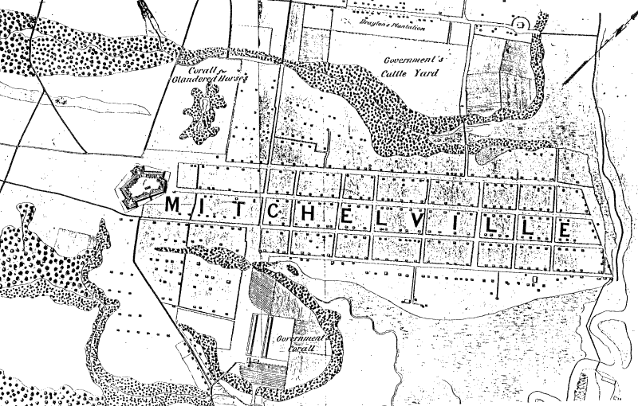
Camp Baird
- 38BU79/1151
Also see Mitchelville.
This area includes a portion of Mitchelville and all of Camp Baird; recommend addition of South Locus which includes four areas of concern:
- Western corner - Civil War Remains
- Disturbed Prehistoric Shell Midden
- Postbellum Domestic Locus
- Eastern Domestic Locus, possibly related to Mitchelville
Brockington, An Archaeological Survey of the 29 Acre Palmetto Headlands Phase V Tract, Beaufort County, South Carolina, p. 25
- 38BU79/1151 Also see Mitchelville. This area includes a portion of Mitchelville and all of Camp Baird; recommend addition of South Locus which includes four areas of concern: Western corner - Civil War Remains Disturbed Prehistoric Shell Midden Postbellum Domestic Locus Eastern Domestic Locus, possibly related to Mitchelville Brockington, An Archaeological Survey of the 29 Acre Palmetto Headlands Phase V Tract, Beaufort County, South Carolina, p. 25
http://www.heritagelib.org/articles/camp-baird
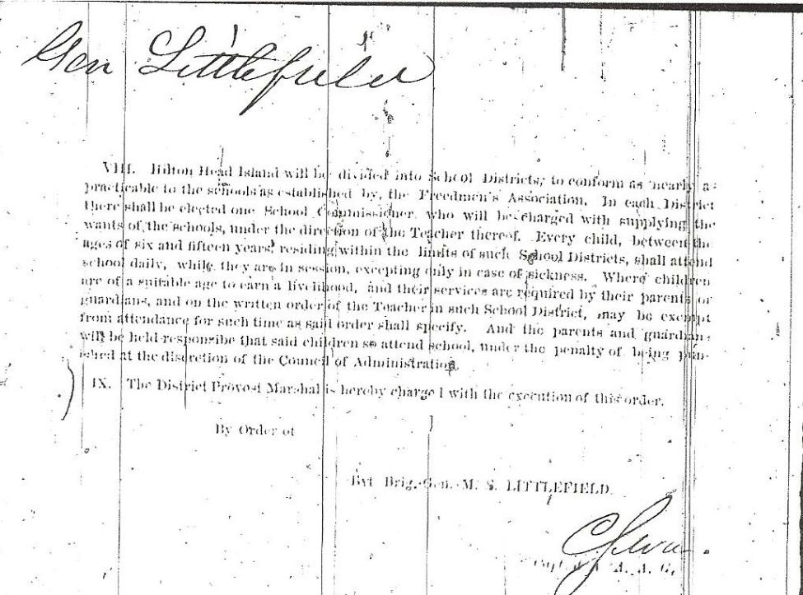

Two brothers, two flags and one battle in Port Royal
http://communities.washingtontimes.com/neighborhood/civil-war/2010/nov/7/two-brothers-two-flags-one-battle-port-royal-sc/#ixzz3Odb0Zrdy

﻿VIENNA, VA.— November 8, 2010 — Two brothers went to war, one with the Confederate Army, the other a Union naval officer. One went north, one went south; both were involved in a naval battle of Port Royal, South Carolina, with which few are familiar, which resulted in a Union victory. Even in death they lie on opposite sides of the Mason-Dixon Line.
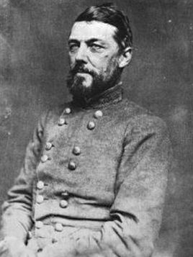

Thomas F. Drayton
﻿The problem with Fort Royal was that the larger Union troops came into the battle with a significant edge over their Confederate opponents who manned two forts, one on either side of the Sound. Fort Walker on the south near Hilton Head, had 23 guns, with 18 of them directed toward the ocean and a fort with as many as 255 men.
On the north, Fort Beauregard on Phillips Island, had 19 guns and a garrison of almost 150 men. Blockading Union ships had patrolled the area throughout the war; it was difficult for the Confederate forces to come into the Sound to refuel or take on coal.
The Union naval forces who attacked them on November 7, 1861 came ‘loaded for bear,’ as they say. The seamen, under the leadership of Flag Officer Samuel duPont, had a total fleet of 75 warships, and several thousand Marines on board, augmented by an Army of 12,000. The only equalizer was the prevailing opinion that naval forces could not outman and outgun land forces. Probably no one really expected that duPont’s men would actually attempt an attack on two forts simultaneously, which was considered to be a project for ground troops.
﻿Still the original battle plan on November 1 had to be abandoned when typical bad Atlantic coastal weather set in. As anyone who has been on more than one Caribbean cruise can attest, the likelihood of strong winds and stronger seas is very likely as one passes Cape Hatteras. On this particular day, the storm was a good strong one, resulting in the naval fleet being scattered with several transport ships being sunk. There would be no attacking the two forts for the time being, and it would be up to duPont to find a way to make it work or face a failure.

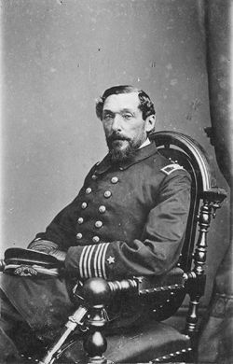

Percival Drayton c. 1864
He was aware that Cape Hatteras had been successfully attacked three months earlier, and felt that by using the force and flexibility of the steam powered ships, he could better take down the fort. DuPont directed his ships to not stop for the actual attack, but to continue moving in such a way that they literally formed an elliptical shape at the mouth of the Sound. In this manner they could attack both Fort Wagner and Fort Beauregard almost simultaneously. This provided the ships the ability to bombard the land forts in a continual barrage, continuing this method as long as was needed. It would be harder for the defenders in the fort to hit moving targets!
On November 7, his plan went into effect and the constant firing continued from 9:30 a.m. until 1:15 p.m. as duPont led his squadron into the Sound. The Rebels met this large force with four ships, a rather uneven match. It was not that much later that the Union sailors saw that the garrison troops appeared to be retreating from Fort Walker, a facet later substantiated when it was found that only three of the guns facing the attackers were still operable.
The losses were light on the Union side, only 31 had been killed or wounded. For the Southerners the figures were not as good since they counted 66 casualties. DuPont’s strategy had worked, Fort Walker was a shell of its former self and the Union Navy still had all of its ships. Shortly thereafter, Fort Beauregard was abandoned. There was now no hope that the Confederacy could prevent Union forces from coming into Port Royal Bay.
The net result was that the Union ended up with an invaluable asset – readily accessible stations for coal and other supplies to keep the blockaders operating. It was a doubly essential area, being located between Charleston, SC and Savannah, GA. And the Union troops had verified their opinion that these two garrisons were always low on ammunition and not staffed adequately.
They had been easy targets.
As to our two young brothers, Brig. Gen. Thomas F. Drayton of the 50th Georgia was a West Point graduate, part of General James Longstreet’s troops, in charge of Fort Royal. Thomas was the eldest, and after the war he went to Mecklenburg County, North Carolina where he died in 1891 and is buried.

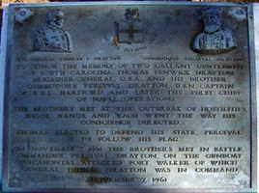

Marker at Port Royal commemorating the Drayton Brothers
His brother, Commodore Percival Drayton, a midshipman, was Captain of the U.S.S. Pocahontas, which was one of the Union fleet. in fact it was to him that Admiral Farragut uttered his famous order, “Damn the torpedoes,full speed ahead!” He, too, survived the war but only barely, dying in August of 1865.
He was buried in Laurel Hill Cemetery in Philadelphia. There stands today a historical marker in Beaufort County, SC, near the gated community of Port Royal Plantation, which reads as follows:
﻿“To honor the memory of two gallant gentlemen of South Carolina. Thomas Fenwick Drayton; Brigadier General, C.S.A. and his brother Commodore Percival Drayton, U.S.N., Captain of U.S.S. Hartford, and later the first Chief of Naval Operations.
The brothers met at the outbreak of hostilities, shook hands, and Each went the way his conscience directed.
Thomas elected to defend his State. Percival to follow his flag.
On November 7, 1861 the brothers met in battle. Commander Percival Drayton, on the gunboat Pocahontas, attacked Fort Walker, on which General Thomas Drayton was in command.”

This article is the copyrighted property of the writer and Communities @ WashingtonTimes.com. Written permission must be obtained before reprint in online or print media.
Recommendations for Further Study:

- AMA schools at Mitchelville
- Government of Mitchelville

